Project Planning Phase
Project Planning Template (Product Backlog, Sprint Planning, Stories, Story points)

Date | 30 September 2026
Team ID | SWTID-2026-1691
Project Name | AI BlogNest API
Maximum Marks | 5 Marks

Product Backlog, Sprint Schedule, and Estimation (4 Marks)
Use the below template to create product backlog and sprint schedule
Sprint | Functional Requirement (Epic) | User Story Number | User Story / Task | Story Points | Priority | Team Members
Sprint-1 | Registration | USN-1 | As an author, I can register by entering my email, password and confirming my password. | 4 | High | Aarthi. V, Abirami. R, Aswin. S, Anushree. P, Bhuvaneshwari. K (Team Leader)
Sprint-1 | Registration | USN-2 | As an author, I will receive a confirmation email once I have registered. | 2 | High | Aarthi. V, Abirami. R, Aswin. S, Anushree. P, Bhuvaneshwari. K (Team Leader)
Sprint-1 | Login | USN-3 | As an author, I can log in with my email and password (JWT). | 3 | High | Aarthi. V, Abirami. R, Aswin. S, Anushree. P, Bhuvaneshwari. K (Team Leader)
Sprint-1 | Post Management | USN-4 | As an author, I can create, edit, view and delete my blog posts (saved as drafts). | 8 | High | Aarthi. V, Abirami. R, Aswin. S, Anushree. P, Bhuvaneshwari. K (Team Leader)
Sprint-1 | Profile | USN-5 | As an author, I can update my profile (name, bio, avatar). | 3 | Medium | Aarthi. V, Abirami. R, Aswin. S, Anushree. P, Bhuvaneshwari. K (Team Leader)
Sprint-2 | AI Content Assistance | USN-6 | As an author, I can generate a draft or outline by giving a topic and keywords. | 8 | High | Aarthi. V, Abirami. R, Aswin. S, Anushree. P, Bhuvaneshwari. K (Team Leader)
Sprint-2 | AI Content Assistance | USN-7 | As an author, I can improve my text (grammar, tone, rewrite) using AI. | 6 | High | Aarthi. V, Abirami. R, Aswin. S, Anushree. P, Bhuvaneshwari. K (Team Leader)
Sprint-2 | AI Content Assistance | USN-8 | As an author, I can get AI-suggested titles, SEO meta description and tags. | 6 | Medium | Aarthi. V, Abirami. R, Aswin. S, Anushree. P, Bhuvaneshwari. K (Team Leader)
Sprint-3 | Publishing | USN-9 | As an author, I can publish, unpublish or schedule a post. | 6 | High | Aarthi. V, Abirami. R, Aswin. S, Anushree. P, Bhuvaneshwari. K (Team Leader)
Sprint-3 | Browse & Search | USN-10 | As a reader, I can browse and search published posts by keyword, tag, category or author. | 8 | High | Aarthi. V, Abirami. R, Aswin. S, Anushree. P, Bhuvaneshwari. K (Team Leader)
Sprint-3 | Engagement | USN-11 | As a reader, I can comment on and like posts. | 6 | Medium | Aarthi. V, Abirami. R, Aswin. S, Anushree. P, Bhuvaneshwari. K (Team Leader)
Sprint-4 | Moderation | USN-12 | As an administrator, I can review and remove inappropriate posts and comments. | 6 | High | Aarthi. V, Abirami. R, Aswin. S, Anushree. P, Bhuvaneshwari. K (Team Leader)
Sprint-4 | API Access | USN-13 | As a developer, I can generate an API key and I am protected by rate limits. | 6 | Medium | Aarthi. V, Abirami. R, Aswin. S, Anushree. P, Bhuvaneshwari. K (Team Leader)
Sprint-4 | Usage Monitoring | USN-14 | As an administrator, I can view platform and AI usage metrics. | 4 | Medium | Aarthi. V, Abirami. R, Aswin. S, Anushree. P, Bhuvaneshwari. K (Team Leader)
Sprint-4 | Documentation | USN-15 | As a developer, I can use interactive API documentation and get clear error messages. | 4 | Medium | Aarthi. V, Abirami. R, Aswin. S, Anushree. P, Bhuvaneshwari. K (Team Leader)

Project Tracker, Velocity & Burndown Chart: (4 Marks)
Sprint | Total Story Points | Duration | Sprint Start Date | Sprint End Date (Planned) | Story Points Completed (as on Planned End Date) | Sprint Release Date (Actual)
Sprint-1 | 20 | 6 Days | 05 Oct 2026 | 10 Oct 2026
Sprint-2 | 20 | 6 Days | 12 Oct 2026 | 17 Oct 2026
Sprint-3 | 20 | 6 Days | 19 Oct 2026 | 24 Oct 2026
Sprint-4 | 20 | 6 Days | 26 Oct 2026 | 31 Oct 2026

Velocity:
Imagine we have a 10-day sprint duration, and the velocity of the team is 20 (points per sprint). Let’s calculate the team’s average velocity (AV) per iteration unit (story points per day)

For AI BlogNest API: sprint duration = 6 days and velocity = 20 story points per sprint, so the average velocity (AV) = 20 / 6 ≈ 3.33 story points per day (80 story points in total over 4 sprints).

Burndown Chart:
A burn down chart is a graphical representation of work left to do versus time. It is often used in agile software development methodologies such as Scrum. However, burn down charts can be applied to any project containing measurable progress over time.
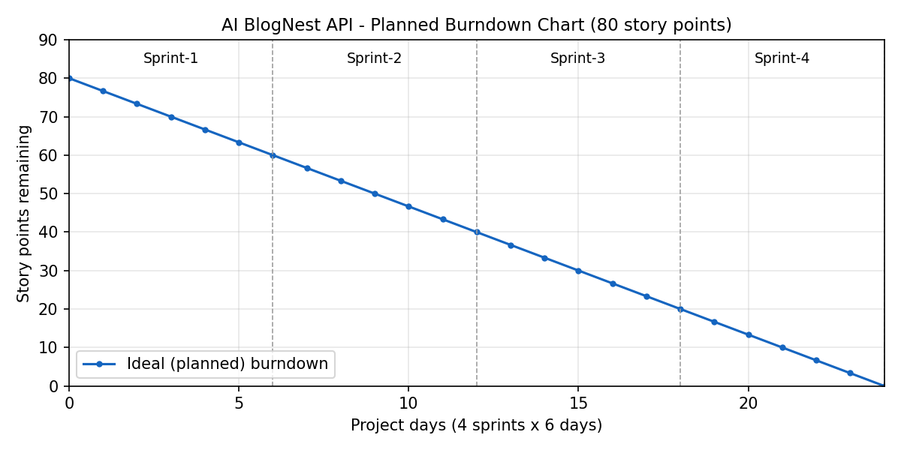

https://www.visual-paradigm.com/scrum/scrum-burndown-chart/
https://www.atlassian.com/agile/tutorials/burndown-charts

Reference:
https://www.atlassian.com/agile/project-management
https://www.atlassian.com/agile/tutorials/how-to-do-scrum-with-jira-software
https://www.atlassian.com/agile/tutorials/epics
https://www.atlassian.com/agile/tutorials/sprints
https://www.atlassian.com/agile/project-management/estimation
https://www.atlassian.com/agile/tutorials/burndown-charts

